**Creating Integration Service Connections**

1. Navigate to **Integration service** option in the Cloud Orchestrator.

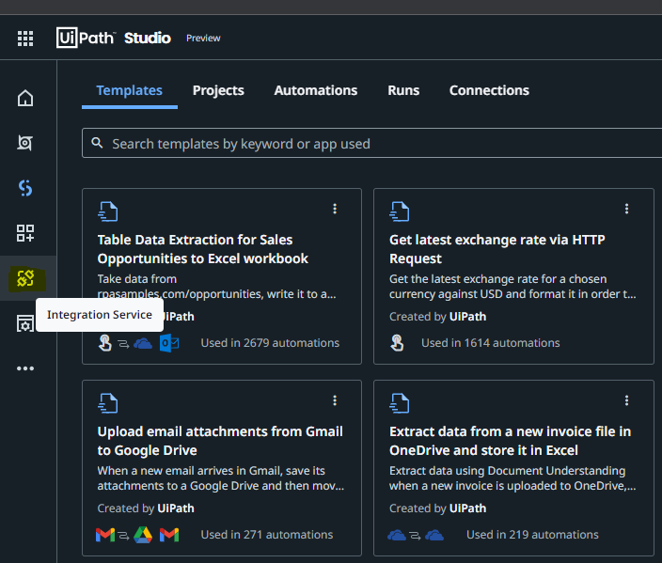

1. Search here for required connection you want to configure for your process.

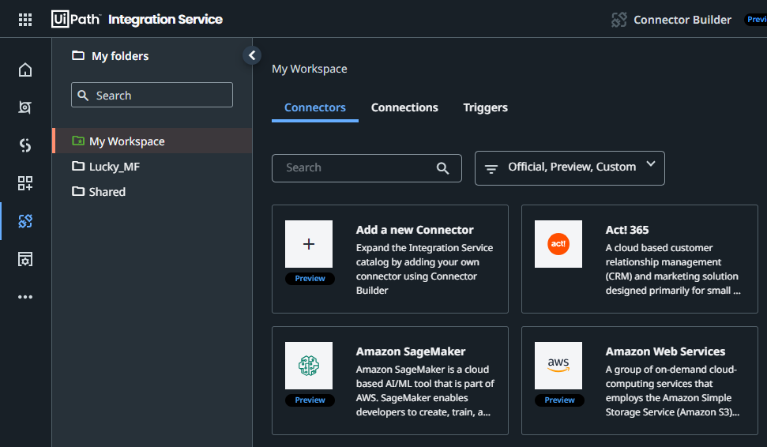

Please check below thread to know more about UiPath Integration service.

<https://docs.uipath.com/integration-service/automation-cloud/latest/user-guide/introduction>

**Creating Gmail Integration connection:**

1. Search for Gmail under Connections section.

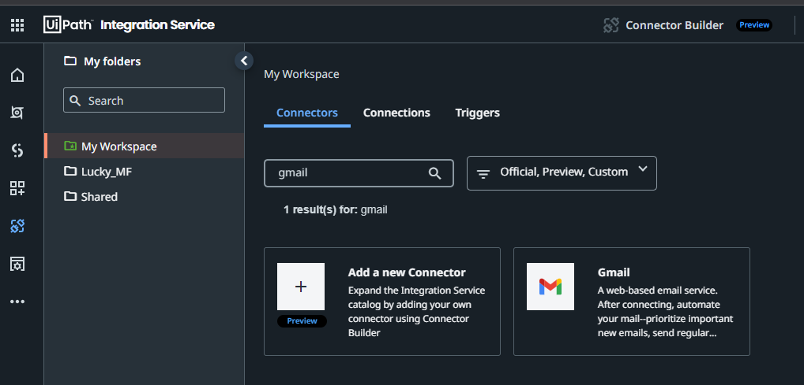

1. Click on **Add Connection**.

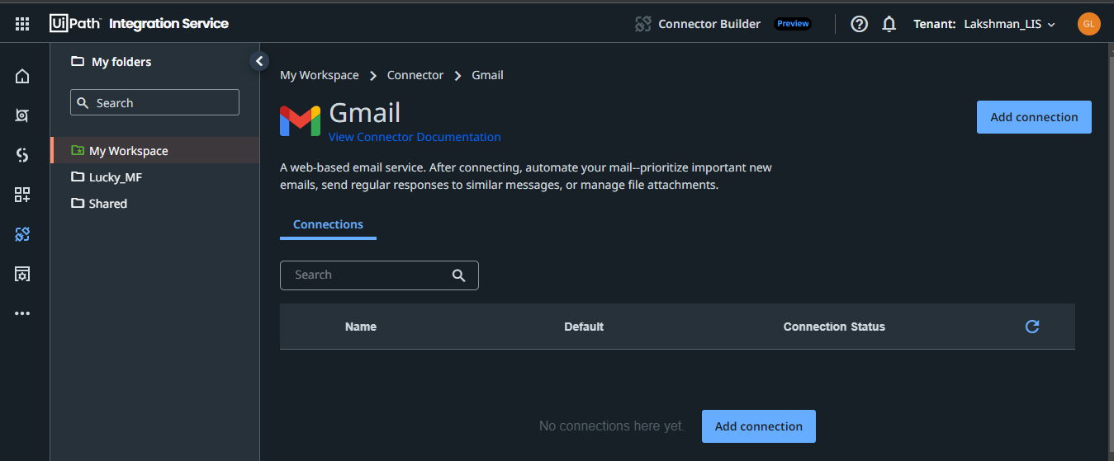

1. Click on **Connect** and provide permissions to access it.

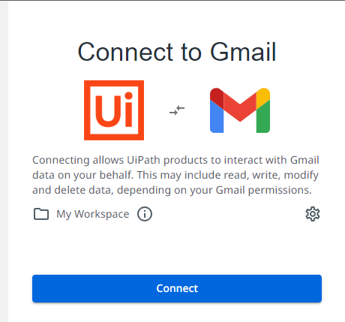

1. Finally, Gmail connection is added successfully.

